Project Documentation

Web Development of SweetSpot - Delivering Delight to Your Doorstep

## Introduction

The e-commerce landscape is constantly evolving, demanding user-friendly and efficient platforms for online shopping. This project, titled "Web Development of sweetspot," focused on creating a cake delivery e-commerce website using Angular 17. By leveraging the functionalities of Angular 17, this project aimed to develop a user-friendly platform for customers to browse, select,customize and order cakes online. This website caters to a growing demand for convenient and personalized cake delivery services, aiming to enhance customer experience and streamline the online cake ordering process.

## Project Scope

The project scope centered on developing essential functionalities to create a user-friendly cake delivery e-commerce website. This core functionality encompasses user login and signup. Product browsing is streamlined with customization options by category (e.g., occasion, flavor) to facilitate a swift search experience.It also includes a user-friendly shopping cart allows for adding, removing, and modifying cake selections, secure checkout and order tracking. While a static checkout and basic order tracking based on distance are included for initial demonstration, future iterations will integrate a secure payment gateway for real-time transactions and a robust order tracking system with live updates, alongside exploring features like user reviews and a mobile application.

## Requirements

The "Web Development of sweetspot" project was guided by a set of functional and non-functional requirements.

### Functional Requirements:

* Users can register and manage accounts.
* A comprehensive product catalog allows for browsing and filtering cakes.
* A user-friendly shopping cart facilitates selection and quantity adjustments.
* A user-friendly shopping cart facilitates selection and quantity adjustments.
* A static checkout page.
* Order tracking keeps customers track their orders in real-time.Integration with Google Maps API for delivery tracking.

### Non-Functional Requirements:

* Intuitive and user-friendly UI design.
* Consistent design across all pages.
* Smooth navigation and quick response times for user actions.
* Compatible with major browsers (Chrome, Firefox, Safari, Edge)

## Technical Stack

**Programming Languages:** TypeScript

**Frameworks/Libraries:** Angular 17

**Data Management:** Local Storage (Angular)

**UI Frameworks/Libraries:** Bootstrap, Google Maps API (Optional for displaying locations)

**Tools/Platforms:** Version Control System (e.g., Git, GitHub), Development Environment (e.g., Visual Studio Code)

## Architecture Design

The "sweetspot" website employs a single-page application (SPA) architecture built with Angular 17. This section delves into the key components and design decisions that shaped the website's structure.

### High-Level Components:

**Presentation Layer (Angular Components):**

* Responsible for user interface elements, data binding, and user interaction.
* Components manage views for browsing cakes, customizing orders, and displaying order tracking information.

**Services Layer (Angular Services):**

* Handle business logic and data access functionalities.
* Services might interact with Local Storage APIs (for initial implementation) or potentially a database (for future iterations) to manage cake data.

**Routing Module (Angular Router):**

* Controls navigation between different sections of the website.
* Users can seamlessly navigate between the cake catalog, shopping cart, and order tracking page.

### Design Decisions:

* **Single-Page Application (SPA) with Angular:** This choice provides a dynamic and responsive user experience, reducing the need for full page reloads.
* **Component-Based Architecture:** Angular's component-based architecture promotes code reusability and maintainability. Each component encapsulates its functionality and UI logic.
* **Local Storage for Data Management (Initial Version):** Local Storage offers a convenient way to manage cake data within the user's browser for the initial development phase.
* **Responsive Design with Bootstrap:** Bootstrap facilitates responsive design, ensuring the website adapts to different screen sizes and devices.

## Development

#### Technologies & Framework:

This project utilized Angular 17 for building the dynamic web application. Local Storage within Angular facilitated data management for cake information (descriptions, images) . Bootstrap provided a foundation for responsive design and UI styling. Additionally, the Google Maps API could be used for location display functionalities.

#### Coding Standards and Best Practices:

The development process adhered to recommended Angular coding standards and best practices. This included utilizing components for modularity, employing dependency injection for loose coupling, and following consistent code formatting conventions.

#### Challenges & Solutions:

The project tackled challenges in:

**Order Tracking:** Accurately reflecting delivery progress with a static distance calculation proved tricky. Potential solutions involve implementing visual progress bars or exploring third-party APIs for simulated delivery tracking.

**Store Management (Local Storage):** Balancing data capacity & complex structures (essential data storage, CRUD operations, consider future database migration).

## Testing

* + Angular supports frameworks like MVC and MVVM.
  + MVC and MVVM supports unit testing.
  + They support Test Driven Development(TDD).
  + Unit testing include testing every function that you write for component, pipe, service etc.
  + Testing verifies whether the expected values and return values are same and will report bugs.
  + Angular is integrated with Jasmine and Karma which are used for unit testing.[ xUnit, Protractor, etc ]

## Deployment

- You can deploy angular application on Local Servers

* XAMPP
* IIS
* WAMP
* MAMP etc.

- You can deploy angular application on cloud servers

* Firebase
* Azure
* AWS
* Now
* Netify
* GitHub Page
* NPM etc.

- Angular can use manual and automated deployment tools. Always recommended to use automated deployment tools

* @angular/fire- firebase
* @azure/ng-deploy
* @zeit/ng-deploy
* Angular-cli-ghpages [Git]
* Ngx-deploy-npm

## User Guide

The "sweetspot" website offers a user-friendly experience for ordering delicious cakes online.

1. **Login or Sign Up:** For a seamless experience, create a user account by clicking "Sign Up" and providing your email address and a password. Or users can simply log in with their credentials.
2. **Browse the Cake Catalog:** Explore our wide variety of cakes by category (e.g., occasion, flavor).
3. **Select Your Category:** Click on products to view different categories that are Pastry, Donuts, Brownies, Cupcakes and Cookies.
4. **Customize Your Order:** Depending on the occasions you can browse different variety of cakes.
5. **Add to Cart:** Click the "Cart Symbol" button to add the desired cake to your shopping cart.
6. **Review and Checkout:** From the shopping cart, you can review your selections, adjust quantities, and proceed to checkout.

## Conclusion

The "Web Development of sweetspot" project successfully delivered a functional e-commerce website for cake delivery. The core functionalities, including user registration, product browsing, product customization, shopping cart management, and a basic order tracking system, provide a user-friendly platform for customers to explore and purchase cakes online.Successfully implemented Online Ordering and Customization Module, Delivery Tracking Module and Store Management Module. This project provided valuable experience in web development using Angular and managing data within a web application.

### Key Achievements:

* **Developed a user-friendly interface:** The website utilizes Angular and Bootstrap to create a responsive and visually appealing experience for users across various devices.
* **Implemented core functionalities:** The project successfully implemented functionalities essential for online cake ordering, enabling users to browse, select, customize, and track their orders.
* **Leveraged Local Storage:** The project utilized Angular's Local Storage capabilities for efficient management of stores data, ensuring store management for administrators.

## Appendices

Screenshots:

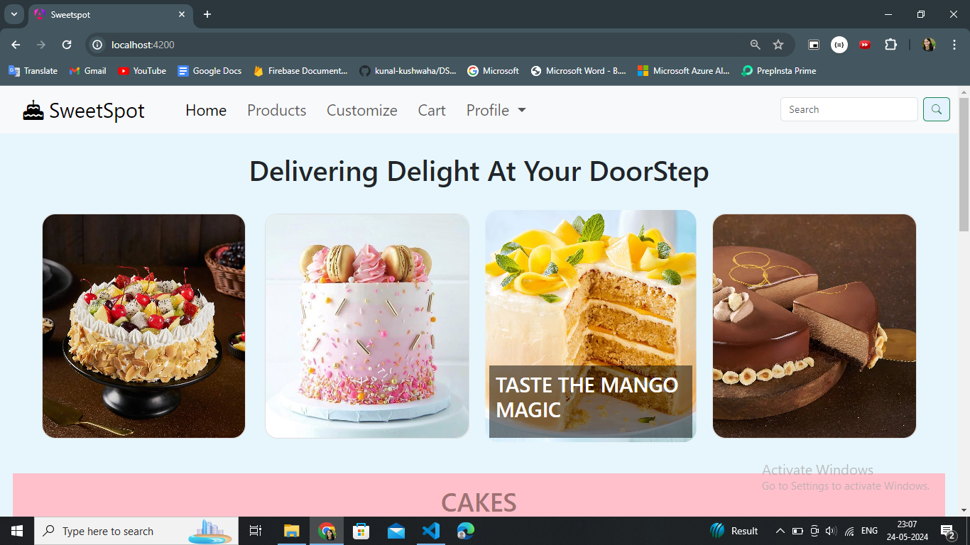

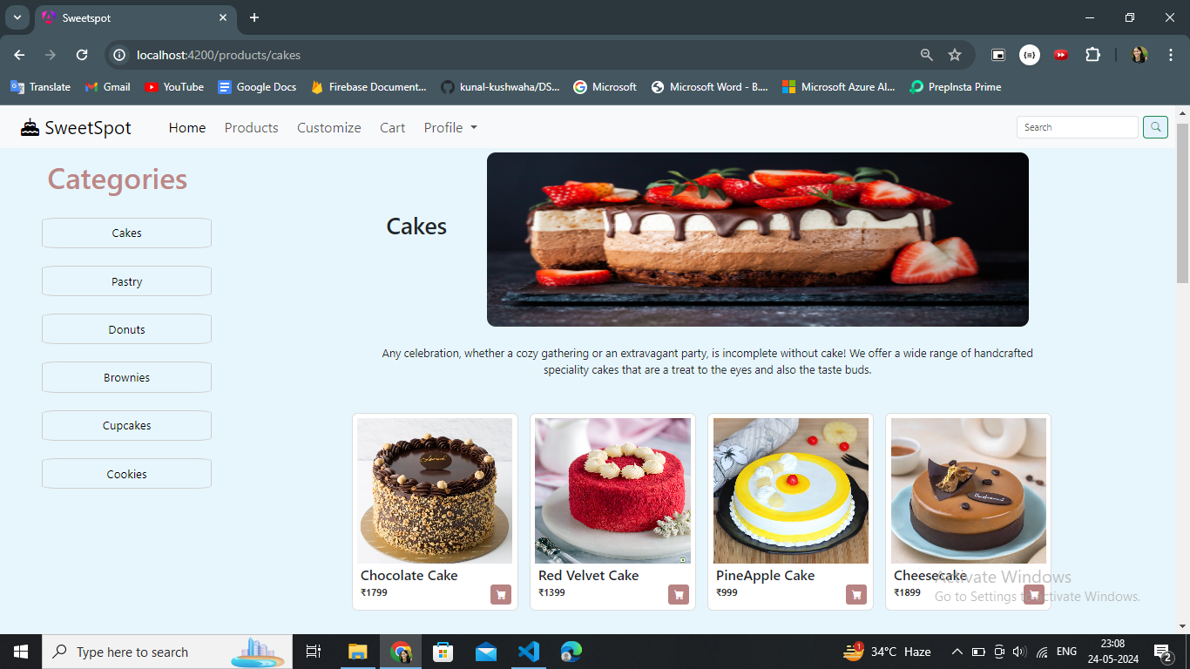

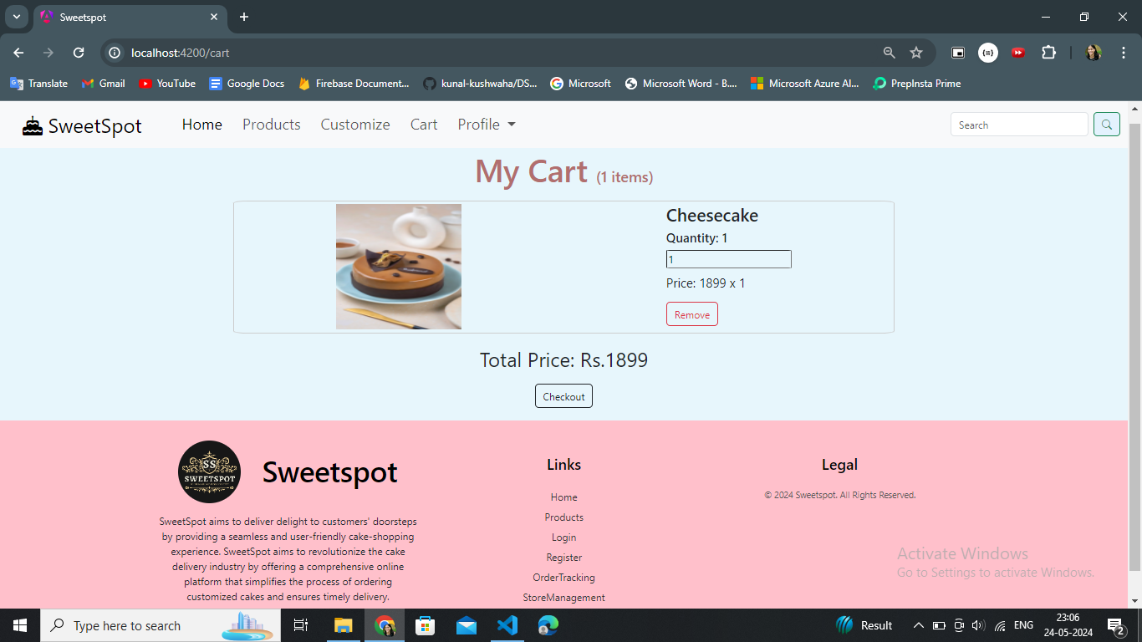

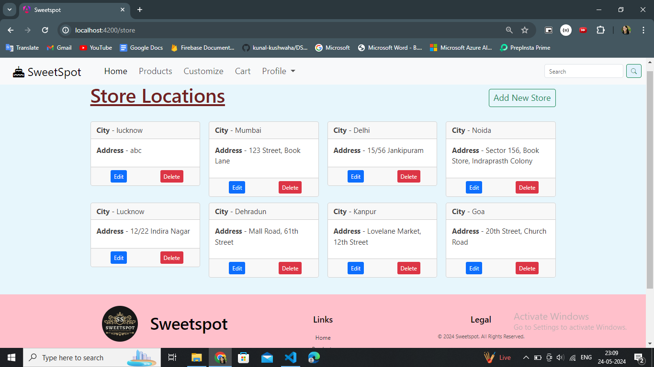

#### Research References:

• Angular Documentation: <https://angular.io/docs>

• Google Maps API Documentation: <https://developers.google.com/maps/documentation> • Bootstrap Documentation:<https://getbootstrap.com/docs>